import cv2  
import matplotlib.pyplot as plt  
import numpy as np  
from scipy.ndimage import convolve  
  
def edge_detection_pipeline(gray_image):  
 """  
 Applies a series of edge detection techniques to a grayscale image.  
  
 Args:  
 gray_image (numpy.ndarray): Input grayscale image.  
  
 Returns:  
 tuple: A tuple containing the processed images:  
 - blurred_gojo (numpy.ndarray): Gaussian blurred image.  
 - magnitude (numpy.ndarray): Sobel filtered image (gradient magnitude).  
 - nms_image (numpy.ndarray): Non-maximum suppression image.  
 - result (numpy.ndarray): Final result after double thresholding.  
 - log_image (numpy.ndarray): Laplacian of Gaussian (LoG) filtered image.  
 - dog_image (numpy.ndarray): Difference of Gaussians (DoG) filtered image.  
 """  
  
 # STEP 1: Noise reduction using Gaussian Blur  
 blurred_gojo = cv2.GaussianBlur(gray_image, (3, 3), 1)  
  
 # STEP 2: Gradient calculation using Sobel filter  
 def sobel_filter(img):  
 kernelx = np.array([[-1, 0, 1], [-2, 0, 2], [-1, 0, 1]])  
 kernely = np.array([[-1, -2, -1], [0, 0, 0], [1, 2, 1]])  
 gx = np.zeros_like(img, dtype=np.int64)  
 gy = np.zeros_like(img, dtype=np.int64)  
 padded_img = cv2.copyMakeBorder(img, 1, 1, 1, 1, cv2.BORDER_REFLECT)  
 for i in range(img.shape[0]):  
 for j in range(img.shape[1]):  
 win = padded_img[i:i+3, j:j+3]  
 gx[i, j] = np.sum(win * kernelx)  
 gy[i, j] = np.sum(win * kernely)  
 result_img = np.hypot(gx, gy)  
 result_img = np.clip(result_img, 0, 255)  
 return result_img.astype(np.uint8)  
  
 magnitude = sobel_filter(blurred_gojo)  
  
 # STEP 3: Non-maximum suppression  
 grad_x = np.zeros_like(blurred_gojo, dtype=np.float64)  
 grad_y = np.zeros_like(blurred_gojo, dtype=np.float64)  
  
 padded_img = cv2.copyMakeBorder(blurred_gojo, 1, 1, 1, 1, cv2.BORDER_REFLECT)  
 for i in range(blurred_gojo.shape[0]):  
 for j in range(blurred_gojo.shape[1]):  
 win = padded_img[i:i+3, j:j+3]  
 grad_x[i, j] = np.sum(win * np.array([[-1, 0, 1], [-2, 0, 2], [-1, 0, 1]]))  
 grad_y[i, j] = np.sum(win * np.array([[-1, -2, -1], [0, 0, 0], [1, 2, 1]]))  
  
 direction = np.arctan2(grad_y, grad_x)  
 nms_image = np.zeros_like(magnitude)  
 angle = direction * 180. / np.pi  
 angle[angle < 0] += 180  
  
 for i in range(1, magnitude.shape[0] - 1):  
 for j in range(1, magnitude.shape[1] - 1):  
 try:  
 q = 255  
 r = 255  
 if (0 <= angle[i, j] < 22.5) or (157.5 <= angle[i, j] <= 180):  
 q = magnitude[i, j + 1]  
 r = magnitude[i, j - 1]  
 elif 22.5 <= angle[i, j] < 67.5:  
 q = magnitude[i + 1, j - 1]  
 r = magnitude[i - 1, j + 1]  
 elif 67.5 <= angle[i, j] < 112.5:  
 q = magnitude[i + 1, j]  
 r = magnitude[i - 1, j]  
 elif 112.5 <= angle[i, j] < 157.5:  
 q = magnitude[i - 1, j - 1]  
 r = magnitude[i + 1, j + 1]  
 if (magnitude[i, j] >= q) and (magnitude[i, j] >= r):  
 nms_image[i, j] = magnitude[i, j]  
 else:  
 nms_image[i, j] = 0  
 except IndexError as e:  
 pass  
  
 # STEP 4: Double thresholding  
 strong_edges = (nms_image > 100)  
 weak_edges = ((nms_image >= 50) & (nms_image <= 100))  
 result = np.zeros_like(gray_image)  
 strong_i, strong_j = np.where(strong_edges)  
 zeros_i, zeros_j = np.where(nms_image == 0)  
  
 result[strong_i, strong_j] = 255  
 result[zeros_i, zeros_j] = 0  
  
 # LoG (Laplacian of Gaussian)  
 def loG(image, sigma):  
 smoothed_image = cv2.GaussianBlur(image, (0, 0), sigma)  
 lkernel = np.array([[0, 1, 0],  
 [1, -4, 1],  
 [0, 1, 0]])  
 result = convolve(smoothed_image, lkernel)  
 return result.astype(np.uint8)  
  
 log_image = loG(gray_image, 2.5)  
  
 # DoG (Difference of Gaussians)  
 def doG(image, sigma):  
 sigma1 = sigma / np.sqrt(2)  
 sigma2 = np.sqrt(2) * sigma  
 G1 = cv2.GaussianBlur(image, (3, 3), sigma1)  
 G2 = cv2.GaussianBlur(image, (3, 3), sigma2)  
 G = cv2.subtract(G1, G2)  
 return G.astype(np.uint8)  
  
 dog_image = doG(gray_image, 2)  
  
 return blurred_gojo, magnitude, nms_image, result, log_image, dog_image  
  
# Example usage:  
gojo = cv2.imread('edge.jpg')  
gojo = cv2.cvtColor(gojo, cv2.COLOR_BGR2GRAY)  
  
blurred_gojo, magnitude, nms_image, result, log_image, dog_image = edge_detection_pipeline(gojo)  
  
# Create subplots  
fig, axes = plt.subplots(2, 3, figsize=(15, 10))  
  
# Display the images in subplots  
axes[0, 0].imshow(gojo, cmap='gray')  
axes[0, 0].axis('off')  
axes[0, 0].set_title('Original Grayscale Image')  
  
axes[0, 1].imshow(blurred_gojo, cmap='gray')  
axes[0, 1].axis('off')  
axes[0, 1].set_title('Gaussian Blurred Image')  
  
axes[0, 2].imshow(magnitude, cmap='gray')  
axes[0, 2].axis('off')  
axes[0, 2].set_title('Sobel Filtered Image')  
  
axes[1, 0].imshow(nms_image, cmap='gray')  
axes[1, 0].axis('off')  
axes[1, 0].set_title('Non-Maximum Suppression Image')  
  
axes[1, 1].imshow(result, cmap='gray')  
axes[1, 1].axis('off')  
axes[1, 1].set_title('Final Result after Double Thresholding')  
  
axes[1, 2].imshow(log_image, cmap='gray')  
axes[1, 2].axis('off')  
axes[1, 2].set_title('Laplacian of Gaussian (LoG)')  
  
plt.tight_layout()  
plt.show()  
  
# Display DoG in a separate plot  
plt.figure()  
plt.imshow(dog_image, cmap='gray')  
plt.axis('off')  
plt.title('Difference of Gaussians (DoG)')  
plt.show()

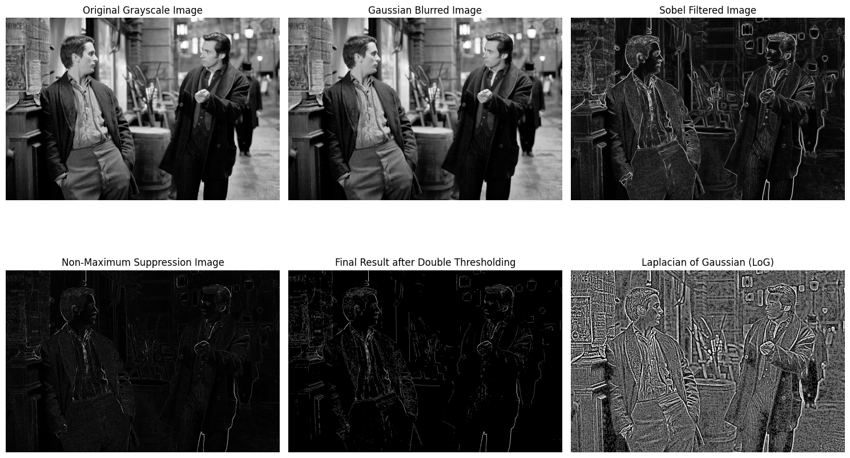

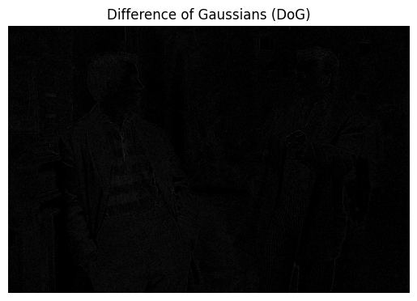

tulips = cv2.imread('download.jpeg') # Replace with the correct path to your image  
tulips = cv2.cvtColor(tulips, cv2.COLOR_BGR2GRAY)  
  
blurred_tulip, magnitude, nms_image, result, log_image, dog_image = edge_detection_pipeline(tulips)  
  
# Create subplots  
fig, axes = plt.subplots(2, 3, figsize=(15, 10))  
  
# Display the images in subplots  
axes[0, 0].imshow(tulips, cmap='gray')  
axes[0, 0].axis('off')  
axes[0, 0].set_title('Original Grayscale Image')  
  
axes[0, 1].imshow(blurred_tulip, cmap='gray')  
axes[0, 1].axis('off')  
axes[0, 1].set_title('Gaussian Blurred Image')  
  
axes[0, 2].imshow(magnitude, cmap='gray')  
axes[0, 2].axis('off')  
axes[0, 2].set_title('Sobel Filtered Image')  
  
axes[1, 0].imshow(nms_image, cmap='gray')  
axes[1, 0].axis('off')  
axes[1, 0].set_title('Non-Maximum Suppression Image')  
  
axes[1, 1].imshow(result, cmap='gray')  
axes[1, 1].axis('off')  
axes[1, 1].set_title('Final Result after Double Thresholding')  
  
axes[1, 2].imshow(log_image, cmap='gray')  
axes[1, 2].axis('off')  
axes[1, 2].set_title('Laplacian of Gaussian (LoG)')  
  
plt.tight_layout()  
plt.show()  
  
# Display DoG in a separate plot  
plt.figure()  
plt.imshow(dog_image, cmap='gray')  
plt.axis('off')  
plt.title('Difference of Gaussians (DoG)')  
plt.show()

